All Saints Church School
Ladies Walk, Montacute, Somerset, TA15 6XG
Tel: 01935 826626 Fax: 01935 825788
e-mail: office@allsaints.bwmat.org Head Teacher: Mrs Sharon Bowditch BAQTS

Thursday 3rd September 2020

Dear Parents and Carers

I hope you have all managed to have a much-needed summer break and spend some quality time with your families. This term is unlike its predecessors in that we are still very much dealing with the consequences of the COVID-19 pandemic and the significant changes to our lives that this has entailed. However, as a staff, we all have a collective enthusiasm for a fresh start to the new academic year along with all the usual feelings that many children also experience - ‘butterflies’ and excitement - both of which are perfectly normal to school life.
We start off the new academic year by congratulating Miss Cameron on managing to adapt her wedding plans to follow the government guidance in order for the much-anticipated wedding to go ahead. Although slightly different, the happy couple were still able to have a fantastic day. We wish Mr and Mrs Babbage all the very best for their future together.

Throughout the holiday period I have continued to follow the changes to Government guidance and advice with regards to COVID-19. As it stands, we will still rigorously follow our updated September 2020 risk assessment. The staggered starts and finishes to the day will help minimise the footfall on site which in turn will also help to keep everyone safe. Please find a reminder about the start and finish times below. For full operational details for September please refer to my letter sent on Monday 13th July. This is still available on our website or can be located on the SZapp within the feed. It is essential that we follow the NHS Test and Trace guidance once children and staff are back in school. Please do not send your child/children to school if they are displaying any of the COVID-19 symptoms. Anyone who displays symptoms of coronavirus (COVID-19) can and should get a test. Tests can be booked online through the NHS testing and tracing for coronavirus website, or ordered by telephone via NHS 119 for those without access to the internet. Thank you in advance.
Organisation of the school day
How will I know what time to arrive at school in the morning and at what time I will need to collect my child?
A staggered start will be in place for September. This will be a different organisation to the summer term as the numbers of pupils on site has increased.
Parents will once again be able to drive into the school grounds and park along the access road during the allocated drop off times. Please try to ensure only one parent/carer brings their child/ children onto site.
Once parked, parents should walk their child/children along the pavement which runs adjacent to the access road, always adhering to the social distancing rules. Please be considerate to others when using the access road; be prompt in returning to your vehicle and leaving the school site.

The two pathways leading from the access road to the main school building will become drop off 1 and drop off 2. Classes A – 3 will use drop off zone 2 and filter into classrooms following the pathway past Acorn Class and onto the playground. Classes 4 – 6 will use drop off zone 1 and filter around the school building, onto the top end of the playground and into classrooms (see map below). SLT, caretakers and TAs will position themselves along the two routes to guide children in the right direction.
New Acorn pupils will be sent a separate letter detailing their first two-week induction timings.

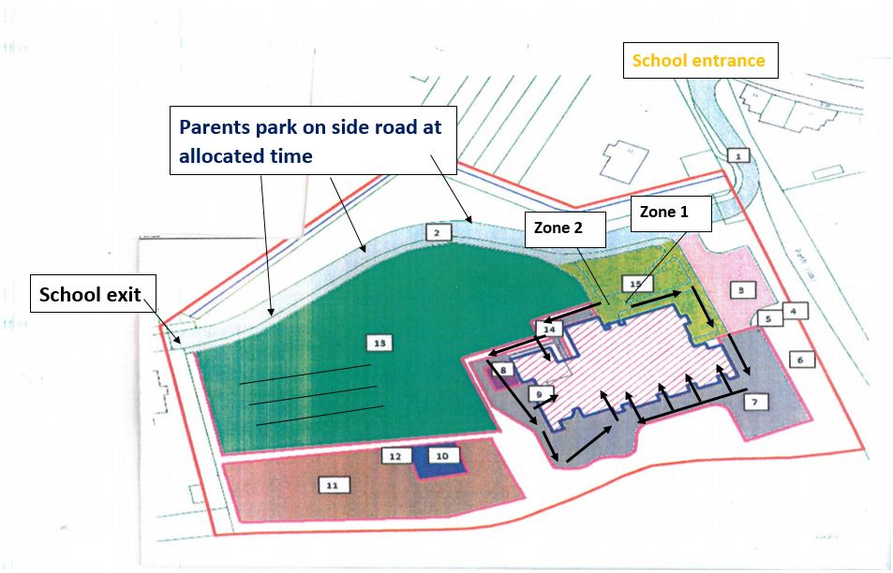

Class | Drop off | AM Location | Finish | PM Location
Acorn (21st Sept) | 09:00 – 09:10 | Zone 2 | 15:00 | Zone 2
Class 1 | 08:30 - 08:40 | Zone 2 | 15:05 | Zone 2
Class 2 | 08:40 – 08:50 | Zone 2 | 15:10 | Zone 2
Class 3 | 08:50 – 09:00 | Zone 2 | 15:15 | Zone 2
Class 4 | 08:30 - 08:40 | Zone 1 | 15:05 | Zone 1
Class 5 | 08:40 – 08:50 | Zone 1 | 15:10 | Zone 1
Class 6 | 08:50 – 09:00 | Zone 1 | 15:15 | Zone 1

At the end of the school day, children will walk out of the school building using the same drop off routes as they used in the morning. SLT staff will ensure children walk safely to their parent/carer.

All children will be required to wear school uniform and have the appropriate P.E. kit ready for P.E lessons. Please do ensure your child’s uniform is named as this helps enormously when returning missing items to their rightful owner. Although September can still be reasonably warm, we do advise that children bring a coat to school. We like to ensure children get as much outside time as we can during the school day, come rain or shine.
May I remind everyone that parents and carers are NOT permitted to enter the playground area of the school until further notice. This is again to support our risk assessment and help us to adhere to social distancing by avoiding pinch points on site. As mentioned in my previous letters, Mrs Sharp or Miss Duffy will be available to take messages to teachers and to answer any questions you may have.
There will be two marquees on site during the Autumn term. These will be used as waiting areas to support those parents who have children being ‘dropped off’ at school at different times. School staff will manage this as children arrive on site.
When children arrive on site at their given start time, class teachers will greet the whole class and once all children have assembled, they will be led around to their classroom.
Finally, I would like to wish you all a positive start to the new term and we are all very much looking forward to welcoming ALL children back to school on Monday 7th September.
Kind regards

Mrs Bowditch

What is the Government saying about a return to school?
How will the school day work?
Schools are expected to teach a broad and balanced curriculum when they return, but the school day may look different to previous years.
Schools are also being asked to:
- stagger start and finish times, without shortening the number of teaching hours each pupil receives
- minimise the number of contacts each pupil has during the day, by putting classes or whole year groups into "protective bubbles"
- avoid assemblies or collective worship with more than one group

Do I have to send my child back?
Attendance will be mandatory again from the autumn term unless pupils or a close contact develop symptoms or test positive for coronavirus.

What about getting to and from school?
There may be staggered start and finish times to keep groups apart and walking or cycling to school will be encouraged. Parents should not gather in groups unnecessarily at school or go into the school (beyond the school gates) without an appointment.
Somerset County Council should be sending letters to those families who use the bus services. This will provide details of how the government guidance is being followed.
https://www.somerset.gov.uk/education-and-families/school-transport/

What else does the government say?
Pupils should:
- wear uniform as normal
- bring only essentials - including lunch boxes, books, stationery and mobile phones
- take books and other shared resources home, but avoid unnecessary sharing - this also applies to teachers
- take part in non-contact physical education - outside if possible - with "scrupulous attention" to cleaning and hygiene

Are there any guidance changes that effect my family and schooling?
If a member of your immediate family has symptoms or have tested positive for coronavirus, you will usually need to self-isolate for at least 10 days.
You will need to self-isolate for 14 days if:
- someone you live with has symptoms or tested positive
- someone in your support bubble has symptoms or tested positive
- you have been told by NHS Test and Trace that you have been in contact with someone who has coronavirus

Launch of the #backtoschoolsafely campaign

The Government have launched a #backtoschoolsafely campaign to reassure parents and students that schools and colleges are ready for their return in September. This is part of the Government’s wider Stay Alert campaign.
Parents are encouraged to visit gov.uk/backtoschool for information and practical guidance to help them plan for their children’s return to school.

