Welcome Year 2 to your home learning.

Dates: Monday 1st June- Friday 5th June
Hello Year Two!
We hope you had a lovely half term and enjoyed your well-deserved rest. The weather has been lovely so we hope you have spent lots of time having fun outside. We love seeing the wonderful things that are getting up to at home via email. Thank you all for continuing to work so hard!
Have a great week everyone!
Love from
Mrs Mill, Mrs Webb, Miss Gardner, Miss White, Mrs Owens, Mrs Sharp and Mrs Copestake
This week we would like you to complete the following work.
Reading | - We recommend that your child reads daily to an adult. You can use their reading book or any books you have at home.  You could choose a book to read from this website:  https://www.oxfordowl.co.uk/for-home/find-a-book/library-page/?view=image&query=&type=book&age_group=Age+7-9&level=&level_select=&book_type=&series= (You might recognise some of these from school)  If you would like to, you could print out this dice and stick it together. Roll the dice and answer the reading dog’s questions about the book you are reading. https://www.twinkl.co.uk/resource/t-l-53545-year-2-roll-and-respond-reading-dice-nets  - In addition please complete the following reading comprehension activities. You do not need to record your answers (unless you want to) but please talk through each question and answer.  You can help your child to become a more fluent reader by reading the following texts: https://www.twinkl.co.uk/resource/ks1-60-second-reads-minibeasts-activity-pack-t-l-527643  https://www.twinkl.co.uk/resource/t-l-52256-year-2-javan-rhinos-differentiated-reading-comprehension-activity The activity gets more challenging from 1 to 3 stars on the bottom left hand side of the activity.
Spelling | Spelling is a really important part of the curriculum and practice makes perfect! Please practise the following spellings daily.  - Please learn these 6 spellings; fearless, careless, hopeless, endless, spotless, helpless. Write out each of your words. Go over the vowels in each word using a coloured pencil. e.g.  - https://www.twinkl.co.uk/resource/tp-l-235-planit-english-y2-term-2b-w1-u-spelt-o-spelling-pack Look at the powerpoint presentation – the ‘u’ sound spelt with ‘o’.  - Have a go at one of the activities on the link above to help you spelling words with the ‘u’ sound spelt with ‘o’.
Writing | This week we will be looking at the Percy the Park Keeper Collection written by Nick Butterworth for our writing. You will probably have read some of his lovely stories. Here are some links for you to watch:  https://www.youtube.com/watch?v=diTpTIyX6AI (The Hedgehog’s Balloon)  https://www.youtube.com/watch?v=7dyCkleWRzo (After the storm)  https://www.youtube.com/watch?v=eTZQ41BzAaI (Badger’s Bath)  https://www.youtube.com/watch?v=Ish40e45d7Y (The Fox’s Hiccups)  Percy the Park Keeper loves to spend time with his animal friends. The animals often need Percy’s help and he is always there to lend a hand.  Try to write your own exciting version of a Percy the Park Keeper story. You could change:  - The main character (maybe you are the park keeper)  - Have different animals  - Have a different problem for the park keeper  - Change the park – Could it be the Lido Park in Droitwich?  Your story doesn’t have to be very long but try to include some adjectives, openers, conjunctions and adverbs.  Don’t forget to use the VCOP writing support on the Year 2 page.
Maths | Times table practice should be done daily. Practice the song, rehearse saying them in full out loud and in order. Really challenge yourself by answering times table questions out of order!  https://www.bbc.co.uk/teach/supermovers/ks1-maths-the-5-times-table/zhbm47h ( 5 times table)  You could learn your times tables by playing hit the button. Try to get quicker each time you play!  https://www.topmarks.co.uk/maths-games/hit-the-button  This week we would like you to recap fractions using the following link:  https://whiterosemaths.com/homelearning/year-2/  Make sure you are on the ‘home-learning year 2’ tab then click week 1 at the bottom. On the week 1 tab, there are 5 lessons focusing on fractions.  1.) Lesson 1- Make equal parts  2.) Lesson 2- Recognise a half  3.) Lesson 3- Find a half  4.) Lesson 4- Recognise a quarter  5.) Lesson 5- Find a quarter  Work through the lessons by watching the video and then try to complete the activities. Remember you don’t have to print it out- you can look at it on the screen and record your answers in your workbook.  Keep your maths brain busy by having a go at the following challenge:  - https://www.twinkl.co.uk/resource/t-n-252431-year-2-fractions-word-problems-challenge-cards  https://www.mathematicsmastery.org/free-resources This website is providing sequenced resources for anyone who would like to do some additional maths practice. You can sign up to be notified when more resources become available.
PE | Physical exercise is really important. Have a go at the following each day. Can you get better the more your practice?  - https://www.youtube.com/watch?v=SH-7A3NVQbY Who doesn’t love a Just Dance Disney party?  - Do 10 toe touches. Reach up high then bend down and touch your toes. Your arms and legs should stay straight. Can you do sitting toe touches?
Computing | Create a minibeast animation using the following link: https://www.j2e.com/jit5#animate  You will need to click on the button that says animals and then change it to minibeasts. Have fun!
Topic | - D.T- If your minibeast home is still in your garden. Have a look to see if there are any minibeasts inside it. Have a go at evaluating your design.  -Are you happy with your design?  -What worked?  -What didn’t work?  -What would you change about your habitat?  - Science-What do we think seeds need to grow? If you have any seeds at home, you could do an experiment to see where the best place for them to grow is. You could put seeds in four different places and regularly check to see which seeds are growing the best. Try the following:  - light, warmth, no water (window sill-no water)  - light, water, no warmth (in a cold place)  - no light, water, warmth (cupboard)  - light, water, warmth (window sill- with water)  - Sports day- Last half term we would have taken part in sports day. You could create your own sports day in your gardens or have a socially distanced sports day with your family at the local park. You could race with your siblings or maybe even a parent/carer. Have a fabulous sports day at home! Don’t forget to take some photos.  Here are some links you might like to use:  https://www.twinkl.co.uk/resource/home-sports-day-leader-board-cfe-hw-50  https://www.twinkl.co.uk/resource/t-c-027-sports-day-award-certificates
Activity | As we are coming to the end of our minibeast topic then why not create a minibeast craft. You could use things that you have around the house or in your garden. E.g. toilet rolls, plastic bottles, egg boxes or stones. Here are some ideas to give you some inspiration:  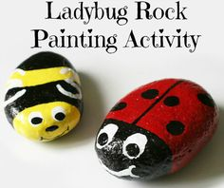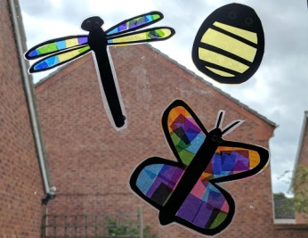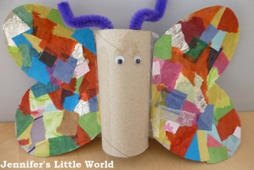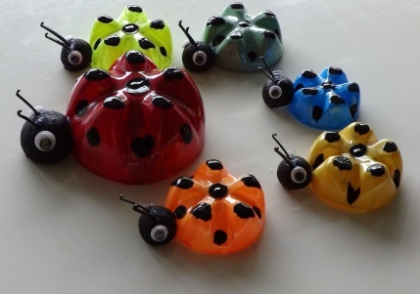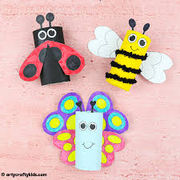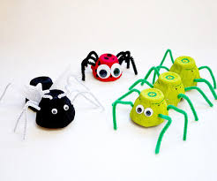  (You might need to zoom in so you can see them clearly)
All parents can access remote learning via Twinkl. You will need to set up a free account by following the link below.
Setting this up is really easy to do - go to www.twinkl.co.uk/offer and enter the code UKTWINKLHELPS

