Welcome Year 3 to your home learning.

Dates: Monday 18.05.2020 - Friday 23.05.2020
Hello from all the staff in Year 3. We hope many of you will have been working hard, keeping up with some learning while at home. Great News! You can now send us some of the work, that we are sure you are proud of, if you would like to. More information and the email address is available from the school homepage link. year3homelearning@chawson.worcs.sch.uk We look forward to seeing how busy you have been!
This week’s activities as usual have plenty to choose from...
Reading | - We recommend that your child reads daily to an adult. You can use their reading book or any books you have at home.  - We would like to share access to some familiar e-books that your children may enjoy reading at home. We use many books by Oxford publishing, and they are currently offering free access to parents to many levelled eBooks on Oxford Owl.  https://home.oxfordowl.co.uk/books/free-ebooks/  To view them you will need to set up an account, but it is quick and free. If you search for title’s by Oxford level, they show up as colours next to them. Your children should know the colour book that were reading so this will enable you to select the right level of text. The children can choose from some books they may have already read, a title that sounds interesting or they might even find the next in the series they were waiting for. It includes some project X books which the children know and enjoy. This week, after choosing an eBook, or one of your own from home if you do not use these, we would like you to use the “authors word choice” sheet available from the Reading sheet tab on the web site home page. Choose some words that the author has used effectively, discuss the meaning within that sentence and say why it was a good word to choose – an activity that you are used to doing in Guided Reading at school.
Writing | This week we would like you to watch - Broken: Rock, Paper, Scissors  https://www.literacyshed.com/a-shed-full-of-animations.html  It’s a fairly short animation that turns the idea of the hand game into 3 characters.  After watching we would like you to talk about what happened in the story discussing events as a comprehension exercise. Discuss the different characters and how they felt about each other at different points in the story.  Choose ONE of the following to try some writing linked to this animation. As well as content remember try and remember your VCOP as well, to make the writing interesting.  - Write character profiles describing appearance and comparing the characters  - Write the story end, from after Paper wakes up  - Write the story from Paper’s point of view  - Make a simple story plan and write over 3 days, the beginning, middle and end  - Write a setting description for each of the characters homes. How are they all different?  - Design a wanted poster for Scissors  - Write the part where Stone tells Paper to come with him including speech and feelings. Try to remember how speech is laid out correctly when you write it.
Writing support documents (Same as last week if already downloaded)
Y1 and Y2 common exception words
https://www.twinkl.co.uk/resource/t-l-6192-common-exception-words-years-1-and-2-alphabet-word-mat
Y3 and Y4 common exception words
https://www.twinkl.co.uk/resource/t2-e-4298-year-3-and-4-common-exception-words-word-mat
VCOP pyramids – 3rd step from the top are typical Y3 level work. Some children might be more comfortable on the 2nd step or be able to use words from lower steps (However children need to know what the words mean and that they are using them correctly)
https://www.twinkl.co.uk/resource/t-l-721-vocp-vocabulary-openers-connectives- punctuation-pyramid-pack-a4
Spelling | Spelling is a really important part of the curriculum and practice makes perfect!  Task 1 - For this week’s spelling we would like you to learn these six year 3 /4 common exception words.  favourite, fruit, February, forwards, famous, forward  It is up to you how you chose to practise these. You could order these by alphabetical order. You could complete a crossword and answer grid on squared paper (squared template below) and write a clue for the meaning for someone in your household to complete.  https://www.twinkl.co.uk/resource/t-n-4357-1cm-squared-editable-paper  You could complete pyramids for each word, write a definition of each word (what it means) or include each in sentence.  Task 2 – Play hangman using only words from the spellings covered so far, up to the end of f. You can have the list in front to help you whether you are the writer or the guesser. https://www.twinkl.co.uk/resource/t2-e-4298-year-3-and-4-common-exception-words-word-mat The Rules if you are not sure. https://ourpastimes.com/how-to-play-hangman-13583023.html
Maths | Tables  How did you do with your speed grids last week? After using hit-the button to practice again try two speed grids again this week. I expect your scores are going up if you are trying to practice them! Remember if there are just one or two facts you find hard to recall without counting in steps, keep getting asked these out of order at random times. Think you’ve cracked the tables 2x 3x 4x 5x 8x 10x ? Then use hit the button to answer the division questions just as fast.  https://www.topmarks.co.uk/maths-games/hit-the-button  Shopping.  Please find attached in the learning folder this weeks’ shopping PDF file.  The first page of the document is a snapshot from a pretend shopping comparison website with 8 products and prices at 4 different supermarkets. Take the opportunity to discuss reading the prices, discussing which are the most expensive and least expensive place to buy each item using the picture.  - You may be able to total all the objects for each supermarket with the questions on page 2.  - To simplify the task, take 2 or 3 items and work out the total if you bought the same bag of shopping at the three different shops. E.g. Nachos and Beans in each supermarket. Remember your written methods you have learned in school. Drawing pictures and exchanging if necessary, or the formal column method with exchange - if you could do this.  Which shop was most expensive?  Which was cheapest?  What was the difference you could save if you shopped at the cheaper shop?  Can you work out change from £2.00?  - An easier activity could be to work out the smallest number of coins and their values needed to pay exactly with for each product from Lowcost supermarket.
PE | Keep active with a video of your choice if not getting out to walk or bike ride regularly in the week. You have the gonoodle channels to choose from or still have Joe from previous weeks. https://family.gonoodle.com/  Joe Wickes https://www.youtube.com/channel/UCAxW1XT0iEJo0TYlRfn6rYQ  - This week you could make a simple circuit of activities for you and your family to follow. You could use just body movements such as star jumps, hopping, squats, or if you have some equipment like a ball, include throws and catches. You could even use food tins as weights to lift. Have fun and see what you come up with. Send us a picture. year3homelearning@chawson.worcs.sch.uk
Computing | Remembering your E-safety we would like you to practice your research skills again this week. Use one of the child search engines as they are safer and remember that the first hits that come up are often just adverts. Two child search engines available are https://www.kiddle.co/ and https://swiggle.org.uk/  - Think of 3 questions to do with any area of interest you have, such as a favourite football team or hobby and practise your typing skills.  - Then thinking of the best words to narrow your search see if you can find out the answers. Not all questions are easy to find so you may need to rephrase your question or search – I tried to find out how old Chawson was but lots of hits came up about our webpages instead!  Children can still need some monitoring whilst freely browsing the internet, despite child friendly search engines, as links can take them away form the initial hits.
Topic | Science- Continue to care for any plants you may have planted and add changes when they happen to any plant diaries you may have.  Do you eat roots, stems, bulbs, leaves, flowers, and seeds? Have a discussion or make a list of any of these plant parts that you think you might eat. Then look at this information PowerPoint and add any parts of a plant that you missed out. https://www.twinkl.co.uk/resource/plants-we-eat-information-powerpoint-roi-t-20162700  Art – Watch the big art clip of using everyday objects to create a huge picture. https://www.bing.com/videos/search?q=art+attack+big+art&&view=detail&mid=8509EB6291F81333F2948509EB6291F81333F294&&FORM=VRDGAR&ru=%2Fvideos%2Fsearch%3Fq%3Dart%2Battack%2Bbig%2Bart%26FORM%3DHDRSC3  With permission first, as there might be a lot of putting away afterwards, could you use objects from around the house to create an image and record it as a photo before you help put all the things away? You could use construction (Lego pieces laid out rather than built), pencils of different colours, tins and packets, clothes, whatever you can find and will put back. It could be small like a ladybird or maybe find colours to make a rainbow. It’s up to you.  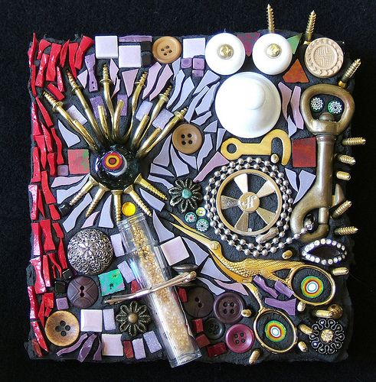  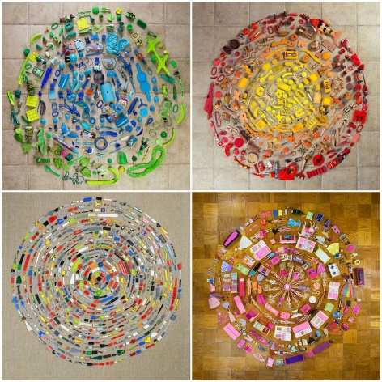  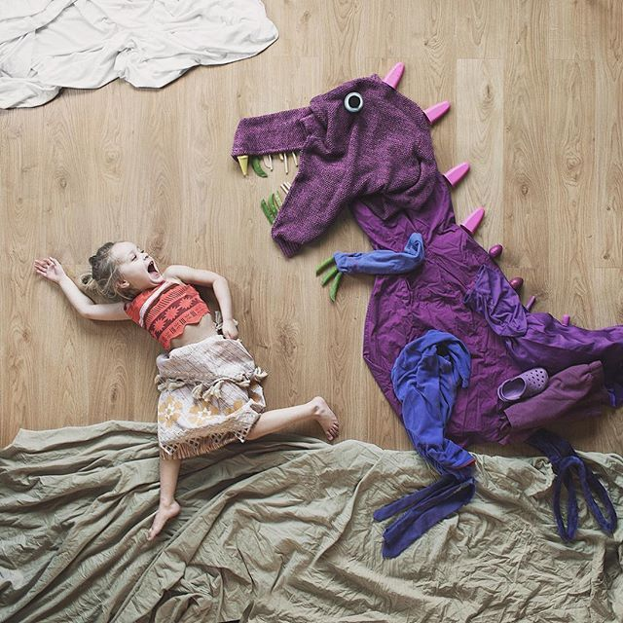  Geography  We would have been looking at maps of Droitwich this half term if in school. Open the link below to find a map of half of the UK.  https://osmaps.ordnancesurvey.co.uk/51.86289,-1.64530,7  Droitwich is positioned to the south of Birmingham towards the middle of the map. As you slowly zoom in can you see how far we are from London, Worcester will come into view. You won’t see Droitwich until Bromsgrove is visible first. Is Droitwich nearer to Birmingham or Worcester? Can you find Chawson school on the map? Can you find your own road? Look around and try and find places in Droitwich that you know. Parks. Town centre. Sports Centre. Train station. The motorway that runs past. If you have any real maps at home, why not take a look at the symbols in the key and see if you can find those things on the map.
Activity | Is your room, a mess? Do your toys need a tidy? Felt tips that need throwing away? Jigsaws all jumbled? Lego pieces under the bed? The 5 items of clothing you tried on all in a pile? If your room needs a little help, I wonder what your before and after pictures you send in might look like!? Why not give a hand to tidy up your own things?  This week’s game to try if you fancy “Battleships” (This, as is the other games I have posted are totally optional!).  Can you find all your opponents’ ships before they find yours? http://www.papg.com/show?1TMC These are instructions for the paper and pencil game I used to play when your age…before the online versions were available!  This online version has more ships but reading the pencil instructions above will help you understand the on-line game better anyway.  http://en.battleship-game.org/
All parents can access remote learning via Twinkl. You will need to set up a free account by following the link below.
Setting this up is really easy to do - go to www.twinkl.co.uk/offer and enter the code UKTWINKLHELPS

