Welcome Year One to your home learning.

Dates: Monday 11th May – Friday 15th May 2020
Hello Year One! We hope you are all OK and have all had a good week. Did you and your family celebrate VE day? We are looking forward to seeing the photographs of you celebrating if your grown ups emailed them to school! We hope you have read the fantastic story that Mrs Thornton has written and illustrated too! ‘Tiny Ant in Lockdown’ is on the school website and the school facebook page if you haven’t seen it.
Keep trying your best and stay safe!
Love from
Miss Trevor, Mrs Parker, Mrs Thornton, Miss Hoban and Mrs Simpson
This week we would like you to complete the following work.
Reading | - We recommend that your child reads daily to an adult. You can use their reading book or any books you have at home.  - In addition please complete the following reading comprehension activities. You do not need to record your answers (unless you want to) but please talk through each question and answer.  - Formidable Sid- reading comprehension activity  - Free e-books to read at home- if you are missing Biff and Chip, there are books on this website to read at home (there are lots of others too!)  - Phonics games – if you haven’t already, spend some time exploring the games on this website. You can still sign up for free to get access to all the games! If you want to recap the sounds you were taught in reception, focus on phase 3 and 4 games. To recap the sounds taught in Year One, focus on phase 5.
Spelling | Spelling is a really important part of the curriculum and practice makes perfect! Please practise the following spellings daily;  - don’t, look, very, it’s, see, back  - Practise writing each of the words 3 times and then play the ‘Missing letter’ game- ask a grown up to write the words out but leave blank spaces in the words. You then have to fill in the gaps by writing the correct missing letters!  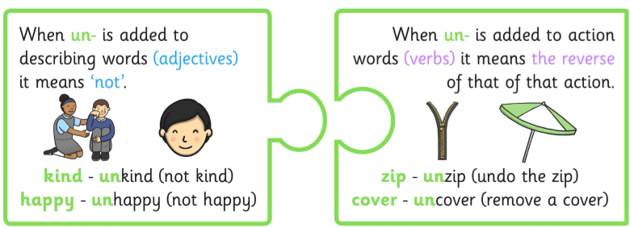  A prefix is a letter or group of letters added to the beginning of a word to make a new word.  Work with someone in your house and think of as many words as you can that start with the prefix ‘un’. Have a go at using each word in a sentence and challenge yourself by writing the sentences down.
Writing | You should now be familiar with Vincent Van Gogh and have done some research to find out all about him.  Choose one of his paintings and imagine that you are in it! Write about what you can see, what you can hear or smell and how you feel.  Don’t forget to use adjectives to make your writing more exciting and remember to use capital letters, full stops and finger spaces!  Read your writing to someone in your house. Can they guess which painting you are in?!
Maths | Counting practice should be done daily. Practice counting forwards and backwards from any number and practice counting in 2’s, 5’s and 10’s.  Have a go practising along with this video. Warning; it is rather catchy!  - Counting in 2's, 5's and 10's workout!  Have a go at these maths activities from White Rose. Remember you don’t have to print it out - you can look at it on the screen and record your answers in your workbook. Watch the video first and then complete the task.  - White Rose Home Learning  Can you remember our work on fact families? Have a go at this game to refresh your brain. Choose the addition and subtraction game and then you can decide what level of challenge you want to complete!  - Addition and subtraction fact families
PE | Physical exercise is really important. Have a go at the following each day. Can you get better the more your practice?  - Footwork skills – use this video for activities to help you develop your footwork skills  - The Body Coach Workout (live every morning at 9am- can you do it every day?!)
Computing | At school, we were learning to program the beebots. Have a go at programming on the computer (you will need to click on the ‘turtle’ tab at the top). Start with the 3 little pigs and program the wolf to visit each of the pigs houses. If you go wrong, don’t worry- find where you went wrong and correct it (this is called debugging).
Topic | This week we will focus on our gardens and if you do not have a garden you could use the local park (as part of your daily exercise walk).  https://www.twinkl.co.uk/resource/t2-sc-013-planit-science-year-1-plants-lesson-3-in-the-garden-lesson-pack  Science – see how many different plants you can find. Take photos of them and then use the internet/books to find out their names and some information about them. This could be whether they grow from bulb or seed/how many different colour flowers they may have/ are they evergreen or deciduous etc.  Geography – draw a map of the garden you have chosen. Challenge – create a key to show things like paths/sheds / flower beds etc. (If it is raining then take a photo of your garden so that you can work on this indoors).  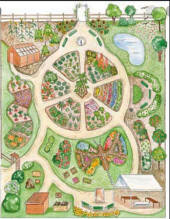  Art – remember our colour mixing from last week – can you choose a flower or plant from your garden and paint a picture of it using your colour mixing skills. Alternatively, use bits of petals, leaves, grass etc that you collect on a walk and stick them together to create a flower/plant picture.  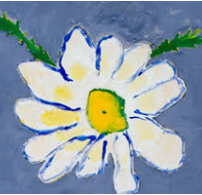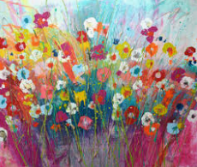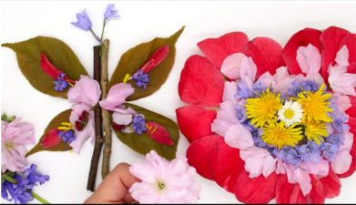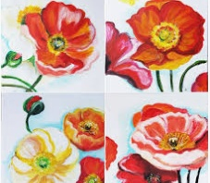  Music – watch this online lesson about high and low sounds  https://www.youtube.com/watch?v=EfeFWXdStgk
Activity | Make people in your house feel happy by leaving them ‘happy notes’ around the home. Could you let them know how much you love them? Could you say ‘Thank you’ for something they have done for you? Could you write something nice about them to put a smile on their face?

All parents can access remote learning via Twinkl. You will need to set up a free account by following the link below.
Setting this up is really easy to do - go to www.twinkl.co.uk/offer and enter the code UKTWINKLHELPS

