ISLANDS IN THE SKY
Hello Chawson,
We have a really exciting task which has been set by Severn Arts and Worcestershire County Council which you might like to complete! We know lots of you like computer games and I bet some of you have dreams of designing one when you are older. As part of a Worcestershire community project, we have been given the chance to help design one.
Islands in the Sky is a computer game where the player moves round mazes and rooms to collect crystals. They have asked for children to help them design a room that could be used in the game. We have a template which you could use and print out or use on the computer to create a design digitally.
We need you to use your imagination to think of an exciting design. Could it be the ultimate club house to relax with your friends in or a spooky room from a haunted house? It is up to you.
Here are some examples:
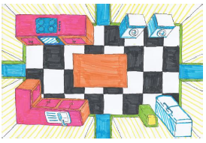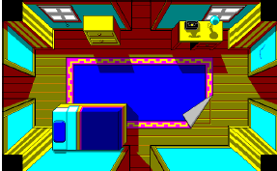
Things to remember when creating your design:
- It is a bird’s eye view of the room. This means you are looking down on the room from above.
- Do not forget the player needs to be able to walk around the room so leave space to get to the doors.

What to do when you have finished
- Ideally we would like you to scan your room design and email it to m.cockcroft@severnarts.org.uk
- Scanner apps on phones will also work well
- Or you can take a clear photograph of your design, making sure your picture is well lit and in the centre.
- If you have created it on the computer email it as a file.

Please email all completed designs by no later than 15 May 2020 to m.cockcroft@severnarts.org.uk and include islandsinthesky in your subject line.
Please also tell them who has created the design and their age(s) and confirm if you are happy for them to include this information on their website. Where possible all of the designs will be used but this does depend on the number they receive.
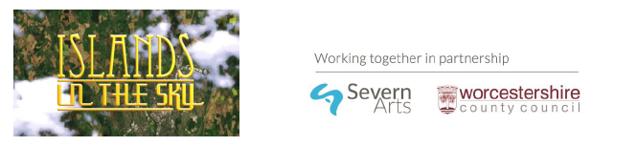
Good Luck!

