Welcome Year Reception to your home learning.

Dates: Monday 27.04.20 – Friday 01.05.20
This week we would like you to complete the following work.
Phonics | - We recommend that your child reads daily to an adult. You can use their reading book or any books you have at home.  - In addition please complete the following phonics activities by clicking on the underlined links.  - Play buried treasure to help practice your real and alien words. We were working within phase 3 and 4- https://www.phonicsplay.co.uk/BuriedTreasure2.html  - Re-cap the sounds ar, or, ow, oi, ur/er . You could make your own flashcards, and then think of words with these sounds in them. E.g. car, born, cow, coin, nurse, tiger
Tricky Words | Tricky words are really important for your child to learn. Please read and spell the following tricky words daily.  - All, they, are, was  - Sing along to the Tricky Word Song  - Look at the pet scrambled sentence sheets to practice more tricky words and writing simple sentences: https://www.twinkl.co.uk/resource/t-t-23716-phase-2-pets-sentence-unscramble
Number | Counting and ordering numbers should be done daily. Keep your maths brain busy by having a go at the following activities:  - Count the animals on these worksheets:  - Numbers 1-10 https://www.twinkl.co.uk/resource/t-n-516-my-counting-worksheet-pets  - Numbers 11-20 https://www.twinkl.co.uk/resource/t-n-5091-national-pet-month-pets-counting-11-20-activity-sheet  - This ladybird game has three different activities, counting, matching and ordering for you to try: https://www.topmarks.co.uk/learning-to-count/ladybird-spots  - One More/One less. Count your teddy collection or any model animals that you have at home. Think about what happens if one teddy/animal runs away or if another one joins the group.
Physical Development | Physical exercise is really important, so this week let’s Dance!  Have a go at the following:  - Join in with this action song: https://www.youtube.com/watch?v=T2qXSMENrQA  - Pick an action card, do the action and see if someone can guess what you are doing or how many can you do in one minute? https://www.twinkl.co.uk/resource/t-m-501--pe-physical-action-cards  - Can you remember our Chinese New year topic? Use this music to create your own Chinese dragon dance: https://www.youtube.com/watch?v=29fSeStUpxs
Topic | Our topic is ‘On the Farm’  - Can you remember any of the animals you learnt about last week and complete this quiz: https://www.twinkl.co.uk/resource/us-t-2547312-farm-animal-what-am-i-interactive-powerpoint  - Watch the webcams at folly farm-  - https://www.folly-farm.co.uk/webcams/  Sometimes the animals might be a little sleepy or not even out but if you keep checking back, who knows what you might see!
Fun Activity | - Acting out farm animals is great fun and can make a good game- how do they move or what noise do they make? Can someone else guess the animal you are trying to be?  - Have you been able to get out on a walk and seen any animals? Could you draw a picture or write about them?  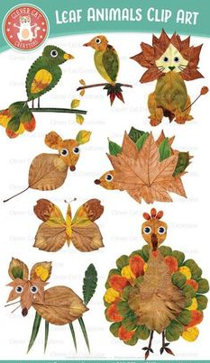  - Could you make a farm animal model using items at home or in the garden? We would love to see your creations on tapestry!  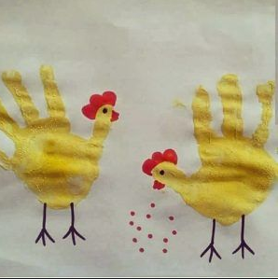  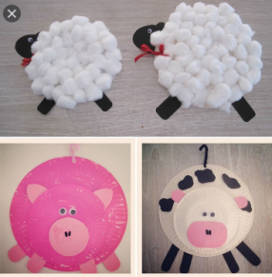

All parents can access remote learning via Twinkl. You will need to set up a free account by following the link below. Setting this up is really easy to do - go to www.twinkl.co.uk/offer and enter the code UKTWINKLHELPS

