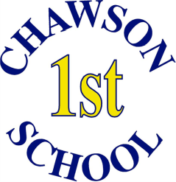
Staff List
We hope you come to know many of our school staff well. These are a few of the people you may meet when you visit.
Our school leadership team:
Headteacher Mrs Helen Wallace
Co-Headteacher and Deputy Miss Nicola Peck
Assistant Headteacher Mrs Karen Sage
Additional Support Coordinator Mrs Lindsay Wood
Maths Coordinator Mrs Denise Smith
School Business Manager Ms Melanie Clarke

Our teachers and teaching assistants:
4W  Mrs Lindsay Wood  Mrs Rachel Plumpton | 3SD  Mrs Denise Smith  Mrs Sue Dickson  Mrs Jenny Groves | 2MW  Mrs Nicola Mill  Mrs Sarah Webb  Mrs Carol Owens | 1T  Miss Kathryn Trevor  Miss Tracy Hoban | RB  Mr Mark Bartle  Mrs Jo Lush
4ER  Mrs Elizabeth Rudkin  Mrs Rebecca Dale | 3K  Mr Chris Kelham  Mrs Anita Nicholson | 2G  Miss Sophie Gardner  Mrs Sarah Sharp | 1PT  Mrs Julie Parker  Mrs Julie Thornton  Mrs Vivian Simpson | RCS  Mrs Emma Collins-Browne  Mrs Karen Sage  Mrs Caroline Rich
4SR  Mrs Suzanne Roberts  Mrs Julie Wood | 3H  Miss Olivia Howse  Mrs Sarah O’Hara | 2W  Miss Holly White  Miss Nicola Spearing |  | RO  Miss Kimberley O’Kane  Mrs Hannah Rushton
Our (very helpful) office staff:
Mrs Sue Brooker- School Administrator
Mrs Kay Beecroft
Mrs Carly Hunt
Mrs Helen Harrison- Finance Assistant
Mr Richard Tidder- Caretaker

