Q1. Here is a table of the number of stamps used each day in school.
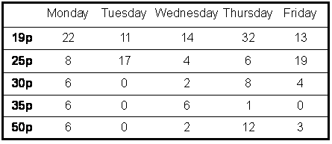

How many 25p stamps did the school use on Wednesday?

1 mark

This is a graph of one kind of stamp they used.
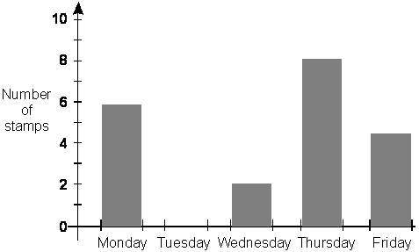

Which stamp is it?

1 mark

Q2. This is a list of the highest temperatures each day for one week.

Day | Temperature
Sunday  Monday  Tuesday  Wednesday  Thursday  Friday  Saturday | 6°C  5°C  8°C  12°C  13°C  11°C  7°C

How many degrees warmer was it on the hottest day than on the coldest day?

°C

1 mark
Here is a chart of the temperatures. Saturday is missing.
Draw in the bar for Saturday.
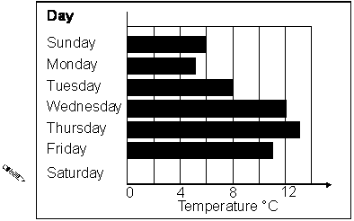
1 mark

Q3. Here is a graph of guitar sales.
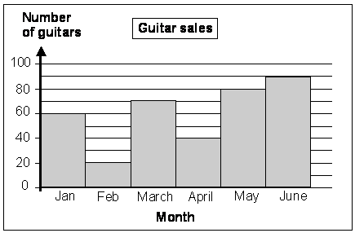

The table below shows the change in sales from month to month.
Use the graph to complete the table.
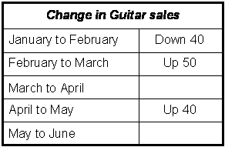
2 marks

Which month had the greatest change in sales compared with the month before?
...............................................................................................................................
1 mark

Q4. Anne makes a graph of buses passing a school in 1 hour.
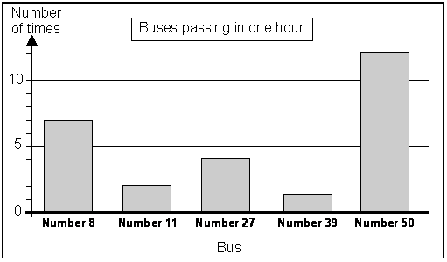

How many times does a Number 27 bus pass in the hour?

1 mark

Anne says,
“Bus number 39 passes least often in the hour.”

Explain how the graph shows this.
...............................................................................................................................
...............................................................................................................................
1 mark
How many more Number 8 buses pass in the hour than Number 11 buses?

1 mark

Q5. Chris did a survey of the number of people who went into shops in one hour.
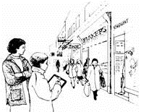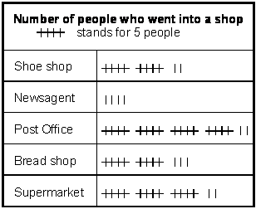

How many people went into the Supermarket in the hour?

1 mark

How many more people went into the Post Office than the Shoe shop?

1 mark

Here is part of a bar chart of the information.
Draw in the missing bar.
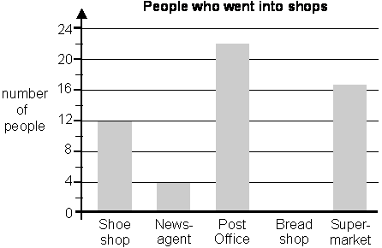
1 mark

Q6.
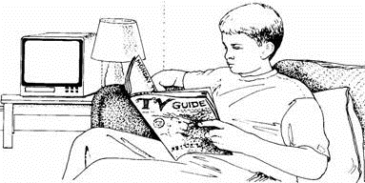
Here are the times of some television programmes.
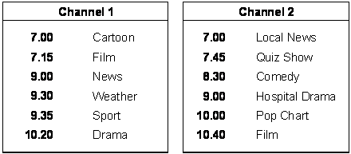

What is showing on Channel 2 at ten minutes to eight?
.......................................................................
1 mark

Tom watches Hospital Drama and then changes to Channel 1 at the end.
What is showing on Channel 1 when he changes channel?
.......................................................................
1 mark

The film on Channel 2 starts at 10.40
It lasts for one and a half hours.
At what time does the film end?

1 mark

Q7. The table shows the number of shirts in a shop.
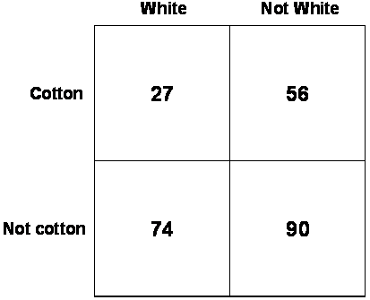

(a) How many shirts are white?
1 mark
(b) How many shirts are there altogether?
1 mark

##
This diagram shows how many children had sandwiches, crisps and fruit in their lunchboxes.
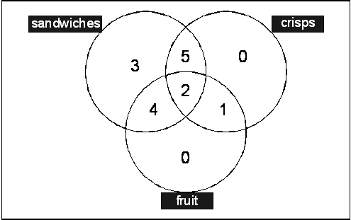
(a) How many children had only sandwiches?

1 mark
(b) How many children had crisps?

1 mark

Q9. Some children drew this graph.
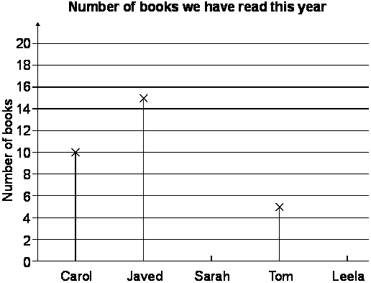

(a) Sarah has read 12 books and Leela 9 books.
Show these on the graph.
1 mark
(b) Javed has read more books than Tom.
How many more?
1 mark

Q10. 28 children timed their journey to school.
The children have written their journey times on this chart.
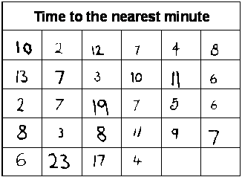

Use the chart to complete the table below.
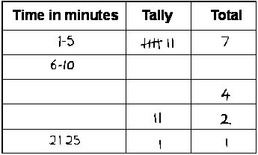
2 marks

Q11. Mandy bounces a ball. She plots the results on this graph.
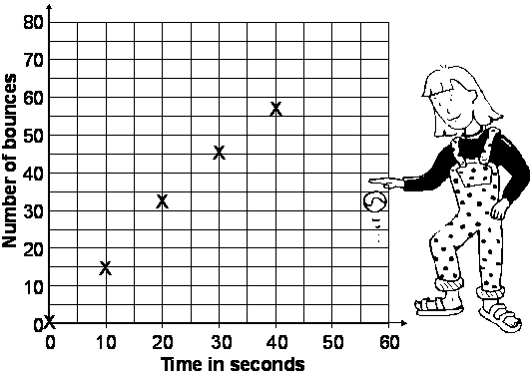
After 50 seconds Mandy has done 65 bounces.

(a) Plot this on the graph.
1 mark
(b) Use the graph to estimate the number of bounces Mandy has done after 35 seconds.
1 mark

Q12. (a) Complete this tally chart.
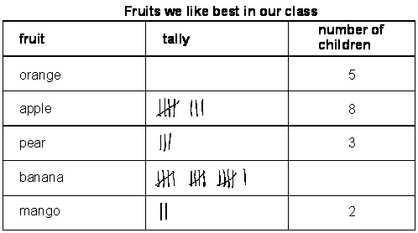
1 mark

(b) The children made this graph from the tally chart.
Put a cross () on the two columns which are wrong.
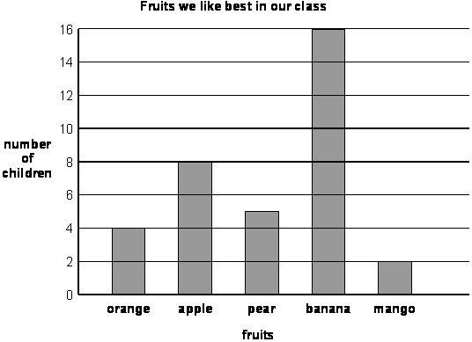
1 mark

Q13. Here is a table of the pets owned by six children.
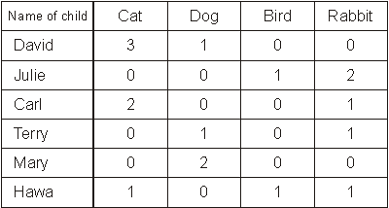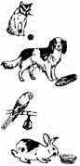

Here is a graph of the pets of five of the children.
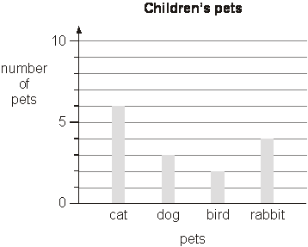

The pets of one of the children are not on the graph.
Whose pets are not on the graph? .. .........................................................
1 mark
Explain how you know.
...............................................................................................................................
...............................................................................................................................
...............................................................................................................................
1 mark

Q14.
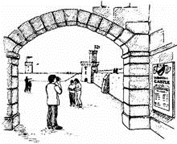
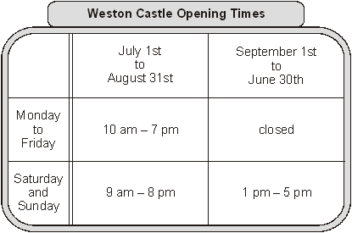
At what time does the castle close on Wednesday July 15th?

1 mark

For which months is the castle open seven days a week?
...............................................................................................................................
1 mark
On Sunday March 8th John goes into the castle at 3 pm.
He stays until closing time.
For how many hours does he stay in the castle?

hours

1 mark

Q15. Patterns are printed on T-shirts.
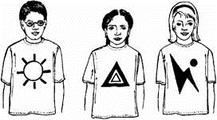
A shop sells 3 sizes of T-shirt, small, medium and large.

The table shows the number of T-shirts sold in one week.
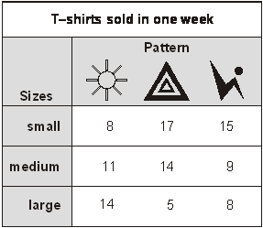

How many medium T-shirts are sold in the week?

1 mark

How many T-shirts with  on them are sold in the week?

1 mark

Q16. Five children sorted themselves into these sets
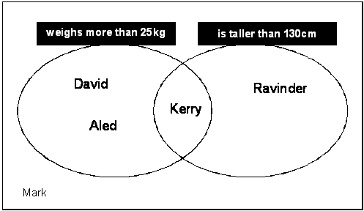

Complete this diagram to show the same information.
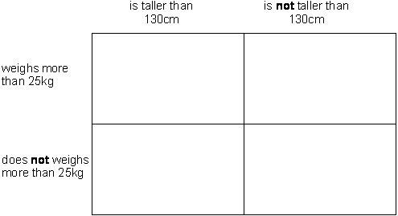
2 marks

Q17. Five children made a graph.
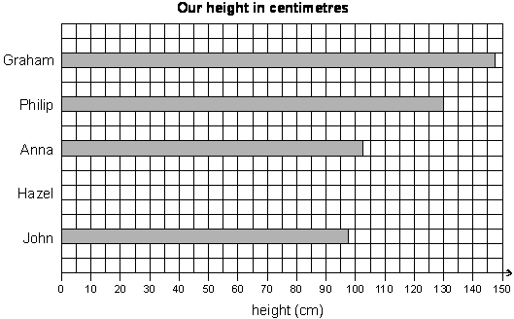
Hazel is 135cm tall.
Show this on the graph.
1 mark

Q18.
Class survey of favourite fruit drinks
flavour | number of children
pineapple | 2
orange | 10
blackcurrant | 8
grapefruit | 6
apple | 9

(a) Complete the pictogram for the class.
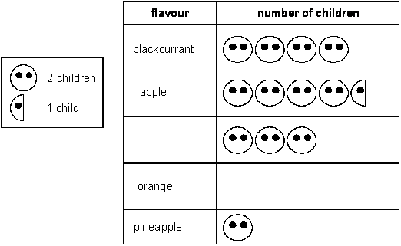
1 mark
(b) How many children altogether chose the three most popular flavours?

1 mark

(c) Write another question you can ask someone about the results of the class survey.
......................................................................................................................
......................................................................................................................
......................................................................................................................
1 mark

Q19.
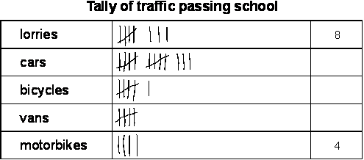
(a) Complete the tally.
1 mark
(b) How many vehicles were seen altogether?
1 mark
(c) Complete this graph using the tally.
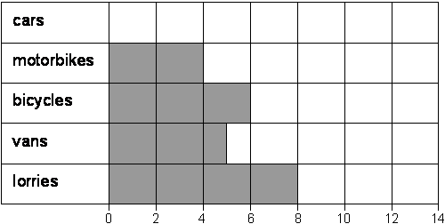
1 mark

Q20. Four children made a graph of their heights.
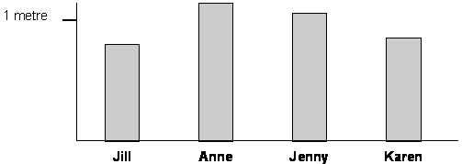
Write their names on the labels.
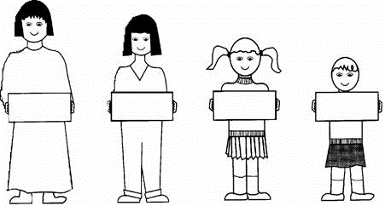
1 mark

Q21. These are the times letters are collected from a post box.
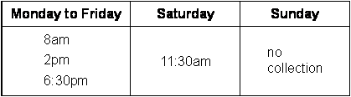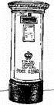

What is the latest time letters are collected on Wednesday?

1 mark

Carla posts a letter at 9 am on Monday.
How long will it be before it is collected?

hours

1 mark

Gareth posts a letter on Saturday at 3pm.
When is it collected from the post box?
day ............................................. time .............................................
1 mark

Q22.
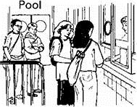
These are the opening times at a swimming pool.
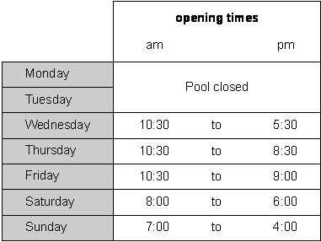

How many hours is the pool open on a Sunday?

hours

1 mark

Which day has the latest closing time?

...............................
1 mark

Habib arrives at the pool at 5:20pm on Saturday.
How many minutes is it before the pool closes?

minutes

1 mark

Q23.
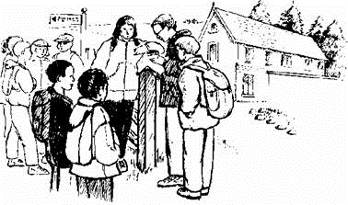
This table shows the numbers of children who went walking, sailing or climbing at
an outdoor centre.

 | May | June | July
walking | 25 | 80 | 75
sailing | 15 | 42 | 50
climbing | 18 | 27 | 23

How many children went sailing in May, June and July altogether?

1 mark
How many more children went walking in June than climbing in June?

1 mark

Q24.
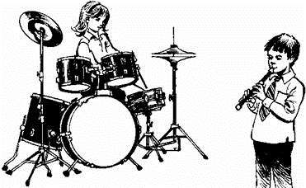
This chart shows the musical instruments some children play.

 | Lena | John | Rashid | Nicola | Yin
drums
keyboard
trumpet
recorder
piano

Who plays both recorder and drums?
...............................
1 mark
How many children play more than two musical instruments?

1 mark

Q25. Tom does a survey of children's favourite breakfast cereals.
These are the results for Class 6
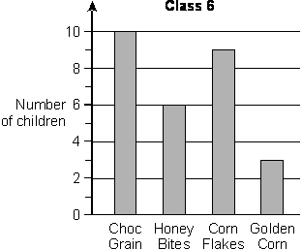

How many more children in Class 6 prefer Choc Grain than Golden Corn?

1 mark

These are the results for Class 5
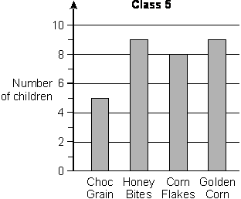
How many children in both classes like Honey Bites best?

1 mark

Q26. Kiz asked each child in his class,
‘What kind of television programme do you prefer to watch?’
Here are his results.
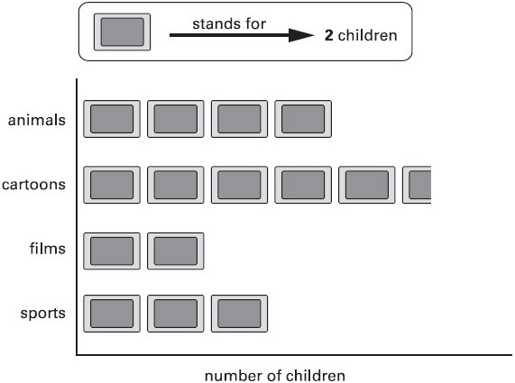
How many more children prefer to watch cartoons than films?

1 mark

Q27. Peter and Stella compare colours they like and do not like.
Here is a sorting diagram that shows their results.
 | Peter likes | Peter does not like
Stella likes |  | 
Stella does  not like |  | 

Write the colours that Stella likes but Peter does not like.
............................... and ...............................
1 mark
Peter likes the colour blue but Stella does not.
Write blue in the correct place on the sorting diagram above.
1 mark

Q28. This graph shows the temperature at midday each day for a week.
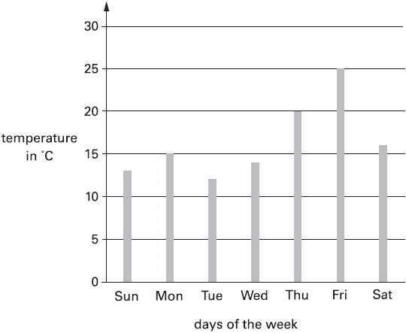

Estimate how much higher the temperature was on Friday than on Saturday.

°C

1 mark

Q29. This graph shows the number of books some children read.
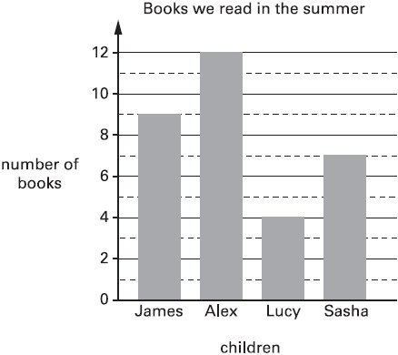

How many more books did James read than Lucy?

books

Which two children read between 5 and 10 books?
............................... and ...............................
2 marks

Q30. Write each letter in the correct place on the diagram.
One has been done for you.
T N P S
 | curved lines | no curved lines
straight lines
no straight lines | S

2 marks

Q31. This graph shows the distance some children walk to school.
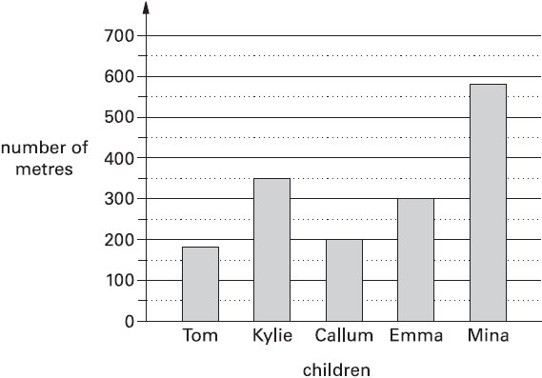

Who walks between 300 and 400 metres to school?
...............................
1 mark

Estimate how many metres Tom walks to school.

m

1 mark

Q32. 60 children visit the zoo.
They each vote for their favourite big cat.
favourite big cat | number of  children
cheetah  | 7
lion  | 22
tiger  | 13
panther 
leopard  | 10
total | 60

Complete the table.

Now look at each sentence below.
Put a tick () if it is true.
Put a cross () if it is not true.

Nine more children voted for the lion than for the leopard. 
The lion was more popular than the tiger.
of the children voted for the tiger.
2 marks

Q33. This graph shows the distance some children walk to school.
Who walks between 300 and 400 metres to school?
...............................
1 mark

Q34. Some children collect cans for recycling.
Here is a chart of how many cans they collect in the first week.
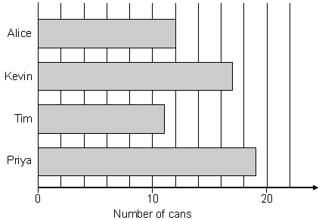
How many cans has Kevin collected?

1 mark

Alice’s target is to collect 30 cans.
How many more cans does Alice need to reach her target?

1 mark

Q35. Some children collect cans for recycling.
Here is a chart of how many cans they collect in the first week.
How many cans has Kevin collected?

1 mark

Alice’s target is to collect 30 cans.
How many more cans does Alice need to reach her target?

1 mark

